ECE 281

Lesson 2 Notes

Instructor: Col Brian J Neff

**Objectives:**

* Know the limitations of a number system (e.g. range)
* Demonstrate the ability to add or subtract binary numbers and correctly identify if there is a carry or overflow

**Lesson Notes:**

**Terminology:** Before we get started, let’s review a few key terms that we discussed in CS 210.



**Byte**



**Nibble**



**Word** – a word is the most convenient size of data for the computer to work with and is highly variable from computer to computer. Common sizes are 16 to 64 bits.



**LSB**



**MSB**



**Overflow** – when adding two numbers together that can’t be accurately represented in the available number of bits

**Carry** - A carry is when the **left most column** has a carry (Internal carries do not result in setting the carry flag

What are the rules for carry in integer addition?



How does that relate to binary addition?



**Ex** – Unsigned binary addition works just like addition with decimal numbers, with the exception that each digit can only take on values of 0 or 1:



1. ) 3 + 5

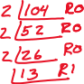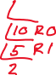

1. ) 10 + 57

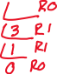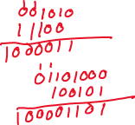

1. ) 104 + 165



Which of the examples above result in overflow if we are using unsigned 8-bit integers



**Binary Subtraction** – The way you were taught with decimal is not efficient to implement in a digital logic device



**Signed Magnitude** –

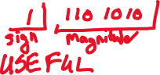

**2’s Complement** –



**Unsigned Binary** –



|  |  |  |  |
| --- | --- | --- | --- |
|  | Signed Magnitude | 2s complement | Unsigned binary |
| Benefits |  |  |  |
| Problems |  |  |  |
| Range |  |  |  |
| Range for N = 4 |  |  |  |



**Keypoints:**

* Overflow will not occur with addition or subtraction of two numbers of opposite sign
  + If carry beyond number of bits occurs… it can be ignored
  + **Ex)** 4-bit 7-7



* If MSB differs from addition of two positive or negative numbers, overflow has occurred
  + **Ex)** 4-bit 7+3

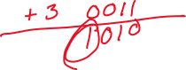

**1st**